NC DKG Committees for 2023-2025: Amy Barsanti is serving on the NC DKG Communications and Marketing Committee. Tracey Reason is serving as the UN/World Fellowship Representative under the Educational Excellence Committee. Phyllis Broughton is serving as NC DKG Leadership Development Chair under the Educational Excellence Committee and on the Educational Foundation Board. Kaye Dotson continues to serve as Regional 1 Director.

New Members 2023
- Mary Taylor Conner teaches kindergarten at Jamesville Elementary School. This past year, she helped organize the “I Like Me” book program. She comments that all kindergarten students in Martin County received a free, personalized book through The Rotary Club of Williamston. During Read Across America week, we had a big read-aloud day where volunteers from the community met at the Innovation Campus to read the book to each student. This was a true 1-1 reading event, and we had volunteers from the Sheriff's Office, Police Department, Martin General, local Fire Departments, local Government, local churches, Rotary, and many others. We are planning for this to be an annual event!
- Dr. Mary Earp teaches at Chowan University in the School of Education. She teaches Introduction to Teaching, Reading, Children’s Literature, and works with Student Teachers.
- Janie Edmondson teaches math at Riverside High School, Williamston.
- Donna Hardison teaches 4th grade ELA/Social Studies at EJ Hayes Elementary School in Williamston. She recently received her AIG Certification in May 2023!

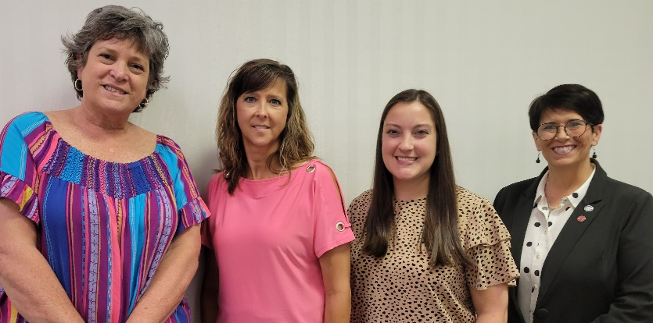
Left to right: Janie Edmondson, Donna Hardison, Mary Taylor Conner, and Dr. Mary Earp

- Martin County
September 9, 2023
Elected Official – Martin County Commissioner Emily Biggs
Program: “Friends of the ECU Library and Teacher Resource Center” by Dr. Kaye Dotson
Induction of New Members

- October 17– Virtual Activity
Activity: “How to Use Google Docs” with Leslie Black, NCDKG Treasurer

- Washington County
November 18, 2023
Program: “NCDKG Updates” with Tammy Cullom, NCDKG Membership Chair
Bazaar
- January 16 – Virtual Activity
Activity: “Becoming a Leader of Excellence” with Carol Ann Hankinson

- Bertie County (Breakfast Meeting)
- February 10, 2024
Program: “DKG International Convention in Finland” with Amy Barsanti
Introduction of Prospective Members

- March 19 - Virtual Activity
Activity: Book Review with Kit Reddick

- Gates/Hertford Counties
April 13, 2024
Vote on Prospective Members
Installation of New Officers
Program: “Nutrition” with April Vaughan, Chowan University

Grant-in-Aid and Collection of Books Schedule
2023-2024 Bertie County
2024-2025 Gates County
2025-2026 Hertford County
2026-2027 Martin County
2027-2028 Washington County

